**Java Basics & OOPs Assignment Questions**

**Java Basics**

1. **What is Java? Explain its features.**

**Java is a high-level, class-based, and object-oriented programming language that is platform-independent and robust.**

**Features:**

**-** Platform Independent: Java bytecode can run on any machine that has a JVM.  
- Object-Oriented: Java supports OOP concepts such as classes and objects.  
- Secure: Java provides a secure runtime environment.  
- Robust: Java has strong memory management and exception handling.  
- Multithreaded: Java supports multiple threads of execution.  
- High Performance: Uses JIT compiler for optimized execution

1. **Explain the java program execution process**.

1. Write Java code and save it as .java file  
2. Compile using `javac` → generates .class (bytecode)  
3. Run the program using `java` command → executed via JVM

1. **Write a simple Java program to display 'Hello World'.**

Java   
public class Hello Java {  
 public static void main(String[] args) {  
 System.out.println("Hello World from Gayatri!");  
 }  
}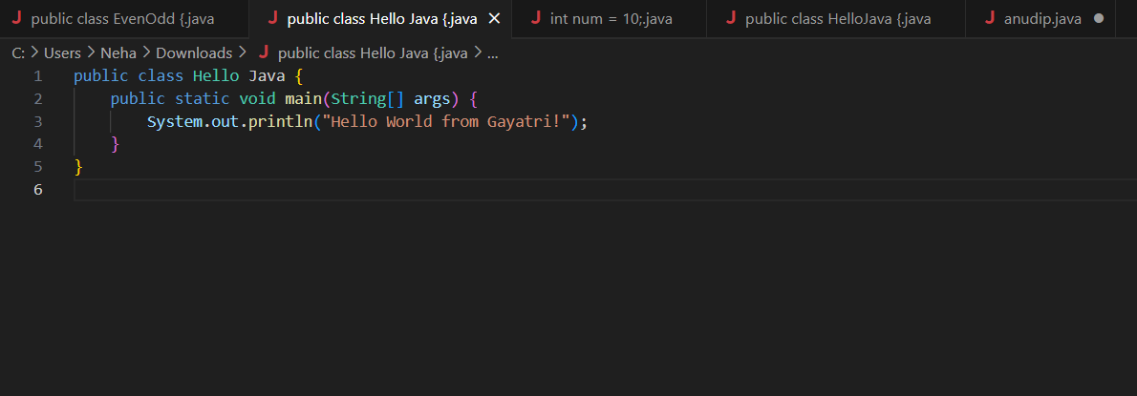

**4. What are data types in Java? List and explain them.**

Java has two types:

- Primitive: int, float, char, double, byte, boolean, long, short  
- Non-Primitive: String, Array, Class, Interface

Example:

java

int age = 22;

String name = "Gayatri”;

**5. Difference between JDK, JRE, and JVM**

| **Term** | **Description** |
| --- | --- |
| JVM | Runs Java bytecode |
| JRE | JVM + libraries (for running Java apps) |
| JDK | JRE + compiler and tools (for developing Java apps) |

**6. What are variables in Java? Explain with examples.**

A **variable** is a container for storing data values.

Example:  
```java  
int marks = 85;  
String student = "Gayatri";

**7. Different types of operators in Java**

* **Arithmetic**: +, -, *, /, %
* **Relational**: ==, !=, >, <, >=, <=
* - Logical: &&, ||, !
* **Assignment**: =, +=, -=, etc.
* **Unary**: ++, --
* **Bitwise**: &, |, ^

**8. Control statements in Java (if, if-else, switch)**

Java

int num = 10;  
if (num > 5) {  
 System.out.println("Greater than 5");  
} else {  
 System.out.println("Less than or equal to 5");  
}  
  
switch(num) {  
 case 10: System.out.println("Ten"); break;  
 default: System.out.println("Other number");  
}

**9. Java program to find even or odd number**

import java.util.Scanner;  
  
public class EvenOdd {  
 public static void main(String[] args) {  
 Scanner input = new Scanner(System.in);  
 int number = input.nextInt();  
 if (number % 2 == 0)  
 System.out.println("Even");  
 else  
 System.out.println("Odd");  
 }  
}  
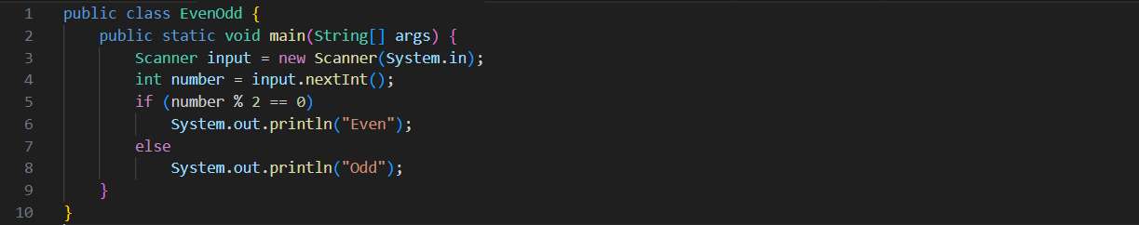

**10. Difference between while and do-while loop**

| **While Loop** | **Do-While Loop** |
| --- | --- |
| Condition checked first | Condition checked after execution |
| May never execute | Executes at least once |

**Object-Oriented Programming (OOPs)**

**1. Principles of OOPs in Java**

* **Encapsulation**: Data hiding using classes
* **Abstraction**: Hiding implementation details
* **Inheritance**: Code reuse through subclasses
* **Polymorphism**: Many forms of methods/objects

**2. What is a class and object in Java?**

class Student {

String name;

void study() {

System.out.println(name + " is studying...");

}

}

public class Main {

public static void main(String[] args) {

Student s1 = new Student(); // object

s1.name = "Gayatri";

s1.study();

}

}

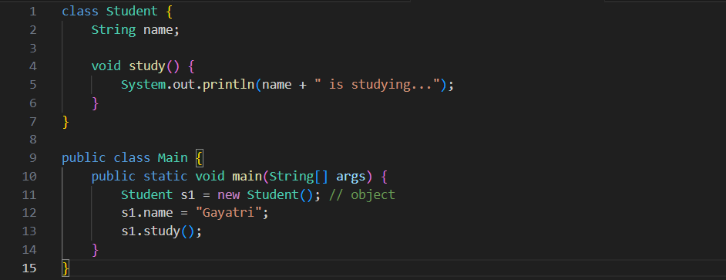

1. **Program to calculate area of triangle**

class Triangle {

double base, height;

double calculateArea() {

return 0.5 * base * height;

}

}

public class Main {

public static void main(String[] args) {

Triangle t = new Triangle();

t.base = 8;

t.height = 4;

System.out.println("Area: " + t.calculateArea());

}

}

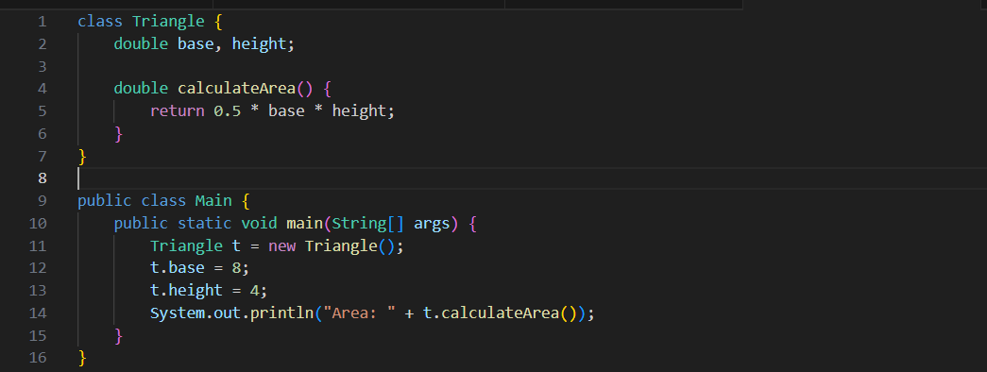

1. **Inheritance with real-life example**

class Vehicle {

void start() {

System.out.println("Vehicle is starting...");

}

}

class Car extends Vehicle {

void drive() {

System.out.println("Car is driving...");

}

}

public class Main {

public static void main(String[] args) {

Car myCar = new Car();

myCar.start(); // Inherited method from Vehicle

myCar.drive(); // Method from Car class

}

}

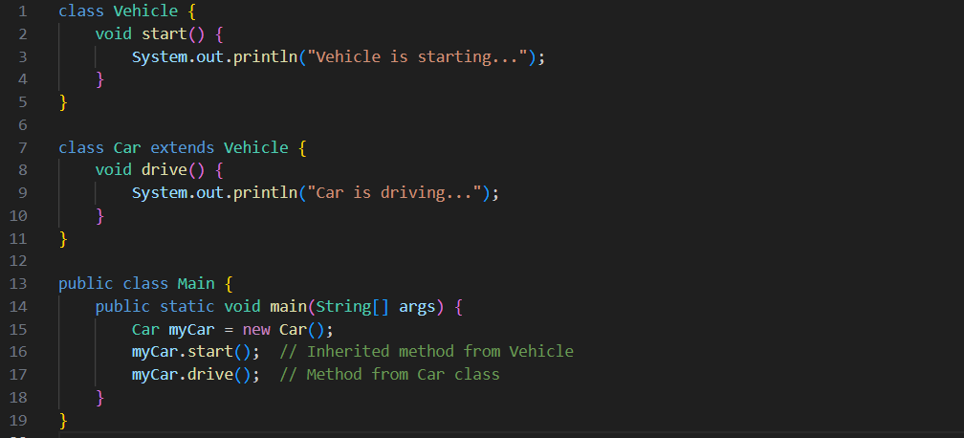

**5. What is polymorphism?**

**Compile-time (method overloading):**

class MathUtils {

    int add(int a, int b) {

        return a + b;

    }

    double add(double a, double b) {

        return a + b;

    }

    int add(int a, int b, int c) {

        return a + b + c;

    }

}

public class Compile {

    public static void main(String[] args) {

        MathUtils mu = new MathUtils();

        System.out.println(mu.add(2, 3));          // 5

        System.out.println(mu.add(2.5, 3.5));      // 6.0

        System.out.println(mu.add(1, 2, 3));       // 6

    }

}

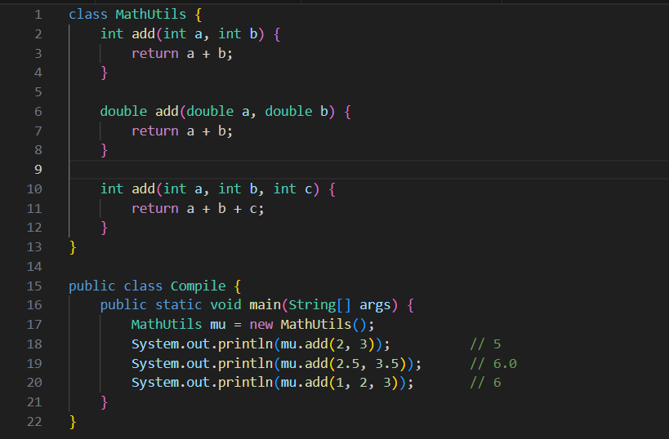

**6. Method Overloading vs Overriding**

**Overloading**: Same method name, different parameters (same class)

**Overriding**: Same method name and parameters in subclass

**7. Program for encapsulation**

public class person {

    private String name;

    private int age;

    public String getName() {

        return name;

    }

    public void setName(String newName) {

        name = newName;

    }

    public int getAge() {

        return age;

    }

    public void setAge(int newAge) {

        if (newAge > 0) {

            age = newAge;

        } else {

            System.out.println("Age must be positive.");

        }

    }

    public static void main(String[] args) {

        person p1 = new person();

        p1.setName("Riya");

        p1.setAge(18);

        System.out.println("Name: " + p1.getName());

        System.out.println("Age: " + p1.getAge());

    }

}

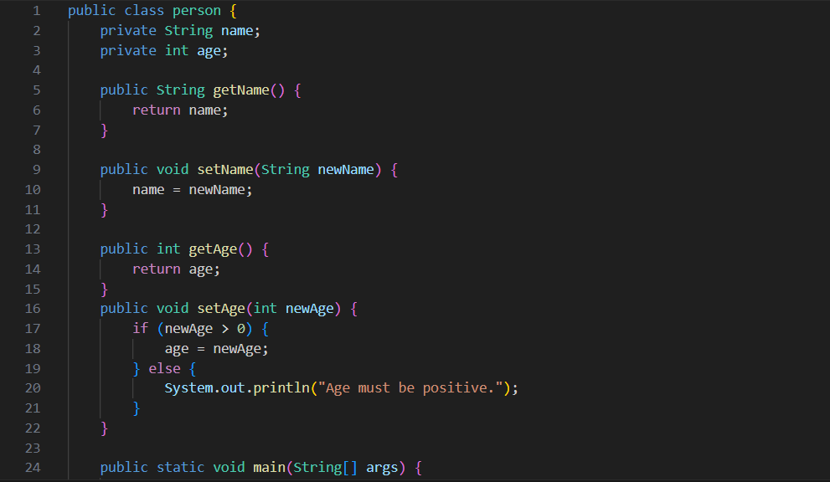

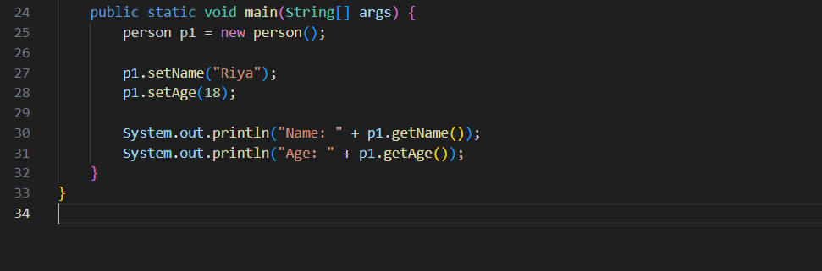

**8. What is abstraction?**

Abstraction means hiding details and showing only essential features. Achieved using:

* **Abstract class**
* **Interface**

**9. Abstract class vs Interface**

| **Abstract Class** | **Interface** |
| --- | --- |
| Can have constructors | Cannot have constructors |
| Can have both abstract and concrete methods | All methods abstract (Java 7) |
| Supports inheritance | Supports multiple inheritance |

**10. Program using Interface**

class Shape {

void draw() {

System.out.println("Drawing a shape");

}

}

class Circle extends Shape {

@Override

void draw() {

System.out.println("Drawing a circle");

}

}

class Rectangle extends Shape {

void draw() {

System.out.println("Drawing a rectangle");

}

}

**public class Runtime {**

public static void main(String[] args) {

Shape s;

s = new Circle(); // object of Circle

s.draw(); // Output: Drawing a circle

s = new Rectangle(); // object of Rectangle

s.draw(); // Output: Drawing a rectangle

}

}



